Young Adult Peer Mentoring Practice Profile:
Promoting Self Care
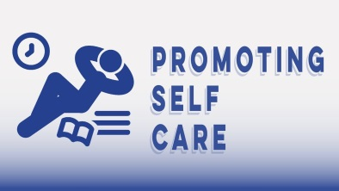
Promoting self-care involves demonstrating resiliency and self-advocacy and providing empathic encouragement to safeguard the overall emotional and physical health of both the YAPM and young adults.
Using lived experience with purpose and intent to promote self-care means:
- Modeling and encouraging overall healthy habits in daily life that have been helpful to the YAPM;
- Encouraging young adult engagement in safe, healthy activities that reduce stress and build positive social connections;
- Sharing resources and strategies for self-care that have been helpful to the YAPM.
- Modeling, through their actions, the ways that YAPM manage challenges that accompany their daily life struggles;
- Demonstrating the self-awareness to understand and manage triggers that may arise for themselves;
- Supporting young adults in managing triggering situations in healthy ways;
- Advocating increasing understanding and decreasing stigma in association of mental health and wellness.
- Supporting young adults in knowing their rights and/or requesting accommodations in education, employment, housing and other life situations;

7 Recommendations to better self-care at work for YAPM
Think of this as a starter list with the goal of minimizing procrastination, help with stress management and maximize a sense of control. As you become more aware of your own unique self-care needs, feel welcome to expand this list by adding your own!
1. Set and maintain professional boundaries.
2. Balance your work schedule and life demands.
3. Make time throughout the work day for intermittent self-care breaks (i.e. lunch or afternoon walk; social time with co-workers; listen to relaxing music).
4. Create a healthy work space for yourself (i.e. hanging pictures, listening to podcast in the car, travel snacks or other sensory items).
5. Develop to do list (2-3 items) of top priorities each day.
6. Before committing to a task, first consider your needs then have honest and open communication with others.
7. Regularly seek out coworkers and natural relationships for support.

For more information, resources and tools, visit: https://www.cbhknowledge.center/yapm-promoting-selfcare

